**ASSIGNMENT 1**

**CASE1**: Please create table called "globetechtb231" and insert below data into it:

create table globetechtb231 (emp_id integer, emp_name varchar(255) not null, job_name |varchar(255) not null, manager_id integer, hire_date integer ,salary integer, commission integer, dep_id integer);

INSERT INTO globetechtb231 ( EMP_ID, EMP_NAME, JOB_NAME, MANAGER_ID, HIRE_DATE, SALARY, COMMISSION, DEP_ID)

VALUES(68319, 'KAYLING', 'PRESIDENT', 0, 1991-11-18, 6000.00, 0, 1001);

INSERT INTO globetechtb231 ( EMP_ID, EMP_NAME, JOB_NAME, MANAGER_ID, HIRE_DATE, SALARY, COMMISSION, DEP_ID)

VALUES(66928, 'BLAZE', 'MANAGER', 68319, 1991-05-01, 2750.00, 0, 3001);

INSERT INTO globetechtb231 ( EMP_ID, EMP_NAME, JOB_NAME, MANAGER_ID, HIRE_DATE, SALARY, COMMISSION, DEP_ID)

VALUES(67832, 'CLARE', 'MANAGER', 68319, 1991-06-09, 2550.00, 0, 1001);

INSERT INTO globetechtb231 ( EMP_ID, EMP_NAME, JOB_NAME, MANAGER_ID, HIRE_DATE, SALARY, COMMISSION, DEP_ID)

VALUES(65646, 'JONAS', 'MANAGER', 68319, 1991-04-02, 2957.00, 0, 2001);

INSERT INTO globetechtb231 ( EMP_ID, EMP_NAME, JOB_NAME, MANAGER_ID, HIRE_DATE, SALARY, COMMISSION, DEP_ID)

VALUES(67858, 'SCARLET', 'ANALYST', 65646, 1997-04-19, 3100.00, 0, 2001);

INSERT INTO globetechtb231 ( EMP_ID, EMP_NAME, JOB_NAME, MANAGER_ID, HIRE_DATE, SALARY, COMMISSION, DEP_ID)

VALUES(69062, 'FRANK', 'ANALYST', 65646, 1917-12-0, 3100.00, 0, 2001);

INSERT INTO globetechtb231 ( EMP_ID, EMP_NAME, JOB_NAME, MANAGER_ID, HIRE_DATE, SALARY, COMMISSION, DEP_ID)

VALUES(63679, 'SANDRINE', 'CLERK', 69062, 1990-12-18, 9000.00, 0, 2001);

INSERT INTO globetechtb231 ( EMP_ID, EMP_NAME, JOB_NAME, MANAGER_ID, HIRE_DATE, SALARY, COMMISSION, DEP_ID)

VALUES(64989, 'ADELYN', 'SALESMAN', 66928, 1991-02-20, 1700.00, 400.00, 3001);

INSERT INTO globetechtb231 ( EMP_ID, EMP_NAME, JOB_NAME, MANAGER_ID, HIRE_DATE, SALARY, COMMISSION, DEP_ID)

VALUES(65271, 'WADE', 'SALESMAN', 66928, 1991-02-20, 1350.00, 600.00, 3001);

INSERT INTO globetechtb231 ( EMP_ID, EMP_NAME, JOB_NAME, MANAGER_ID, HIRE_DATE, SALARY, COMMISSION, DEP_ID)

VALUES(66564, 'MADDEN', 'SALESMAN', 66928, 1991-09-28, 1350.00, 1500.00, 3001);

INSERT INTO globetechtb231 ( EMP_ID, EMP_NAME, JOB_NAME, MANAGER_ID, HIRE_DATE, SALARY, COMMISSION, DEP_ID)

VALUES(68454, 'TUCKER', 'SALESMAN', 66928, 1991-09-08, 1600.00, 0.00, 3001);

INSERT INTO globetechtb231 ( EMP_ID, EMP_NAME, JOB_NAME, MANAGER_ID, HIRE_DATE, SALARY, COMMISSION, DEP_ID)

VALUES(68736, 'ADNRES', 'CLERK', 67858, 1997-05-23, 1200.00, 0, 2001);

INSERT INTO globetechtb231 ( EMP_ID, EMP_NAME, JOB_NAME, MANAGER_ID, HIRE_DATE, SALARY, COMMISSION, DEP_ID)

VALUES(69000, 'JULIUS', 'CLERK', 66928, 1991-12-03, 1050.00, 0, 3001);

INSERT INTO globetechtb231 ( EMP_ID, EMP_NAME, JOB_NAME, MANAGER_ID, HIRE_DATE, SALARY, COMMISSION, DEP_ID)

VALUES(69324, 'MARKER', 'CLERK', 67832, 1992-01-23, 1400.00, 0, 1001);

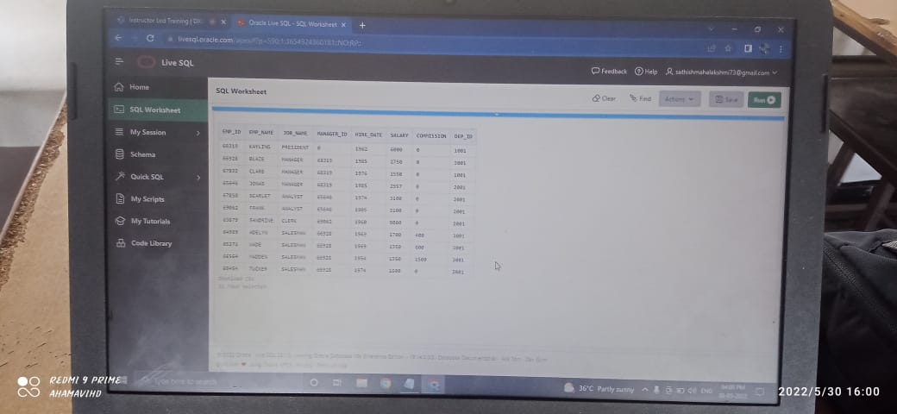

**CASE 2**: From the above table, write a SQL query to find the salaries of all employees. Return salary

SELECT SALARY FROM globetechtb231

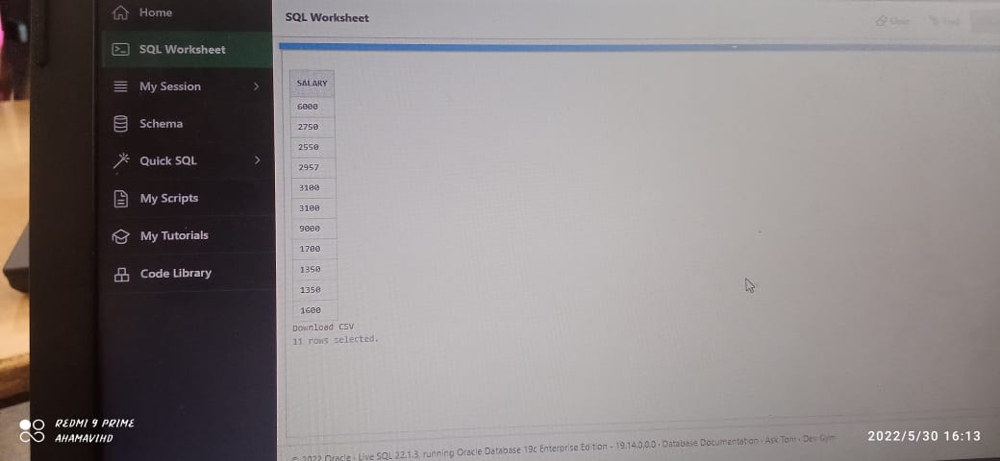

**CASE 3**: From the above table, write a SQL query to find the unique designations of the employees. Return job name.

select job_name

from globetechtb231;

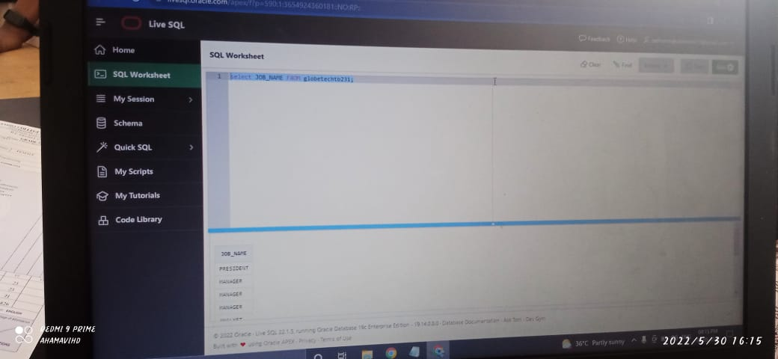

**CASE 4:**

From the following table, write a SQL query to list the employees’ name, increased their salary by 15%,

and expressed as number of Dollars.

SELECT emp_name,

to_char(1.15*salary,'$99,999') AS "Salary"

FROM globetechtb231;

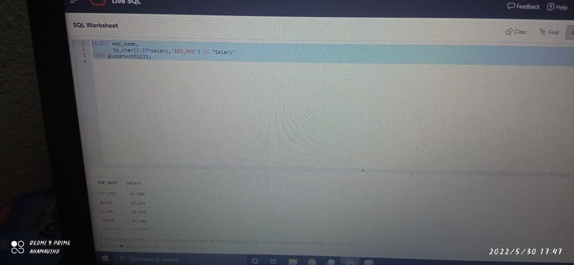

**CASE 5:**

SELECT emp_name|| ' ' ||job_name AS "Employee & Job"

FROM globetechtb231 ;

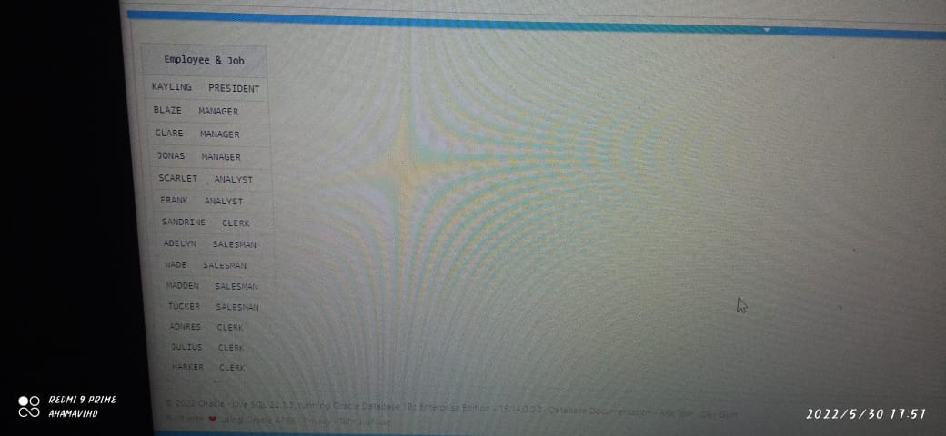

**CASE 6:**

From the same table - Write a query in SQL to produce the output of employees as follows

Employee

JONAS(manager).

SELECT emp_name ||'('|| lower(job_name)||')' AS "Employee"

FROM globetechtb231;

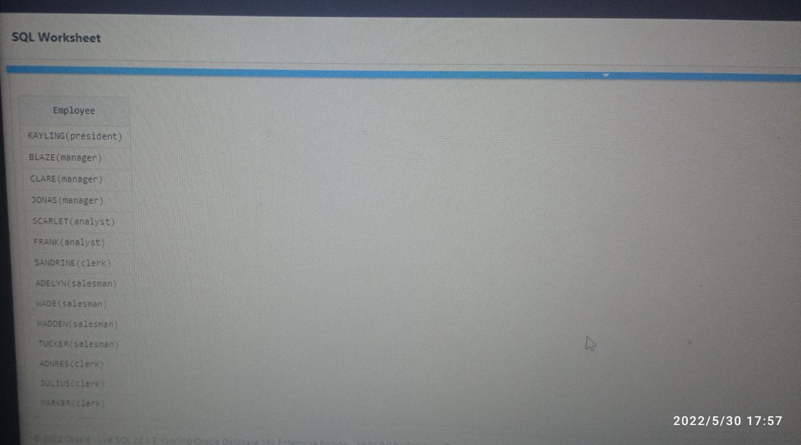

**CASE 7:**

From the above table, write a SQL query to find those employees with hire date in the format like February 22, 1991.

Return employee ID, employee name, salary, hire date

SELECT emp_id,

emp_name,

salary,

to_char(hire_date,'MONTH DD,YYYY')

FROM globetechtb231;

**CASE 8:**

From the above table, write a SQL query to count the number of characters except the spaces for

each employee name. Return employee name length.

SELECT length(trim(emp_name))

FROM globetechtb231;

